Lylah had her birthday. Her mom put some purple candles on the cake and some pink candles on the cake. How many purple candles did she have? How many pink candles does she have? How many candles is there altogether?

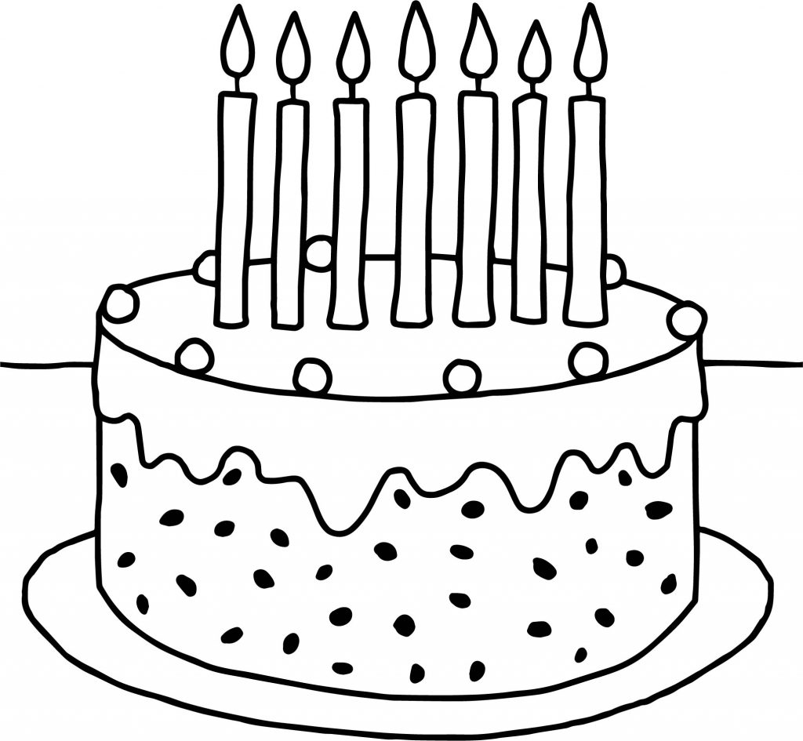

Lylah got 4 presents from her friends. She got 5 more presents from her family. How many presents did Lylah get altogether?

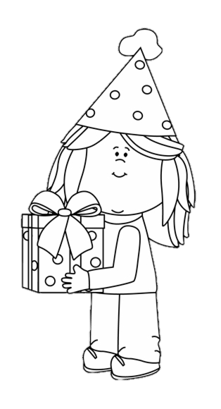

Lylah had a birthday party. She invited 10 friends. 4 of her friends couldn’t go to the party. How many friends went to the party?
